**CSE 370 – Database Systems**

**Theory Section 15/16 | Assignment 02 | Sample Solution**

**Spring 2024**

**Question 1 [CO1] : 20 Points**

Suppose that each of the following Update operations (a-j) is applied directly to the database state shown in Figure A2_1. **Consider each operation independent of each other. Each operation will be performed in the same state of Figure A2_1.** Discuss all integrity constraints violated by each operation (check Figure A2_2 for Referential integrity constraints on the database of Figure A2_1), if any, and the different ways of enforcing these constraints.

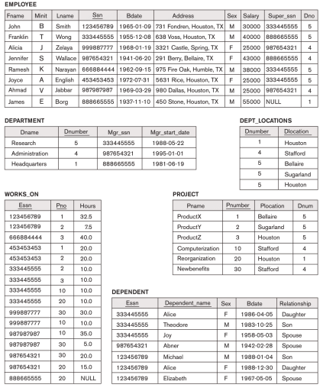

Figure A2_1 : COMPANY database.

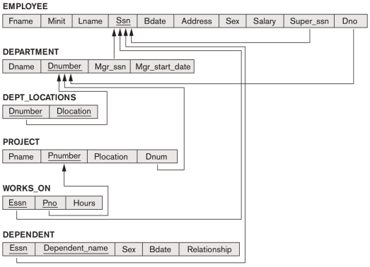Figure A2_2 : Referential integrity constraints on the COMPANY database of Figure A2_1.

| **a.** Modify the HOURS attribute of the WORKS_ON tuple with ESSN= '999887777' and PNO= 10 to '5.0'.  **Answer:**  No constraint violations. |
| --- |
| **b.** Insert <'ProductA', 4, 'Bellaire', 2> into PROJECT.  **Answer:**  Violates referential integrity because Dnum=2 and there is no tuple in the DEPARTMENT relation with Dnumber=2. We may enforce the constraint by: (i) rejecting the insertion of the new PROJECT tuple, (ii) changing the value of Dnum in the new PROJECT tuple to an existing Dnumber value in the DEPARTMENT relation, or (iii) inserting a new DEPARTMENT tuple with Dnumber=2. |

**c.** Insert <'Production', 5, '987987989', '2007-10-01'> into DEPARTMENT. **Answer:**

Violates both the key constraint and referential integrity. Violates the key constraint because there already exists a DEPARTMENT tuple with Dnumber=5. We may enforce this constraint

| by: (i) rejecting the insertion, or (ii) changing the value of Dnumber in the new DEPARTMENT tuple to a value that does not violate the key constraint. Violates referential integrity because Mgr_ssn='987987989' and there is no tuple in the EMPLOYEE relation with Ssn='987987989'. We may enforce the constraint by: (i) rejecting the insertion, (ii) changing the value of Mgr_ssn to an existing Ssn value in EMPLOYEE, or (iii) inserting a new EMPLOYEE tuple with Ssn='987987989'. |
| --- |
| **d.** Insert <'677678989', NULL, '40.0'> into WORKS_ON.  **Answer:**  Violates both the entity integrity and referential integrity. Violates entity integrity because Pno, which is part of the primary key of WORKS_ON, is null. We may enforce this constraint by: (i) rejecting the insertion, or (ii) changing the value of Pno in the new WORKS_ON tuple to a value of Pnumber that exists in the PROJECT relation. Violates referential integrity because Essn='677678989' and there is no tuple in the EMPLOYEE relation with Ssn='677678989'. We may enforce the constraint by: (i) rejecting the insertion, (ii) changing the value of Essn to an existing Ssn value in EMPLOYEE, or (iii) inserting a new EMPLOYEE tuple with Ssn='677678989'.  **e.** Insert <'453453453', 'John', 'M', '1990-12-12', 'Spouse'> into DEPENDENT. **Answer:**  No constraint violations. |
| **f.** Delete the EMPLOYEE tuple with Ssn = '333445555'.  **Answer:**  Violates referential integrity because several tuples exist in the WORKS_ON, DEPENDENT, DEPARTMENT, and EMPLOYEE relations that reference the tuple being deleted from EMPLOYEE. We may enforce the constraint by: (i) rejecting the deletion, or (ii) deleting all tuples in the WORKS_ON, DEPENDENT, DEPARTMENT, and EMPLOYEE relations whose values for Essn, Essn, Mgr_ssn, and Super_ssn, respectively, is equal to'333445555'. |
| **g.** Delete the WORKS_ON tuples with Essn = '333445555'.  **Answer:**  No constraint violations. |
| **h.** Modify the Super_ssn attribute of the EMPLOYEE tuple with Ssn = '999887777' to '987987988'.  **Answer:**  Violates referential integrity because the new value of Super_ssn='987987988' and there is no tuple in the EMPLOYEE relation with Ssn='987987988'. We may enforce the constraint by: (i) rejecting the deletion, or (ii) inserting a new EMPLOYEE tuple with Ssn='987987988'. |
| **i.** Delete the PROJECT tuple with Pname = 'ProductX'. |

| **Answer:**  Violates referential integrity because two tuples exist in the WORKS_ON relations that reference the tuple being deleted from PROJECT. We may enforce the constraint by: (i) rejecting the deletion, or (ii) deleting the tuples in the WORKS_ON relation whose value for Pno=1 (the value for the primary key Pnumber for the tuple being deleted from PROJECT). |
| --- |
| **j.** Modify the Mgr_ssn and Mgr_start_date of the DEPARTMENT tuple with Dnumber = 5 to '123456789' and '2007-10-01', respectively.  **Answer:**  No constraint violations. |